16. Apache sling selector manipulation in AEM

**How to test the sling resolution working (let’s use selector here to test)?**

When a page is requested/opened in browser (<http://localhost:4502/content/we-train.html> ), which is using the template pointing to the page component we create earlier, sling will first look if the path is found in the repository or not. Once found, it looks for sling:resourceType property and execute the script there in the component.

As in the above ex URL, we don’t any selector specified, the default script would get executed and display the content on the page.

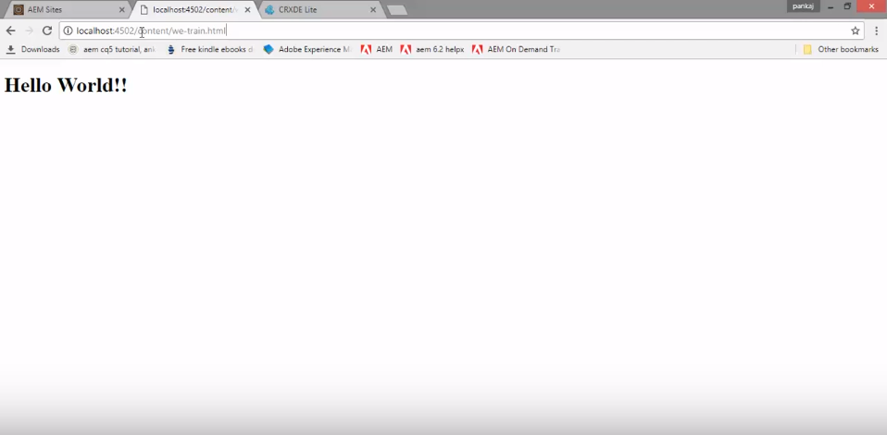

As we are already have a page component created in our project. Let’s create one more file named “blue.html” as shown below.

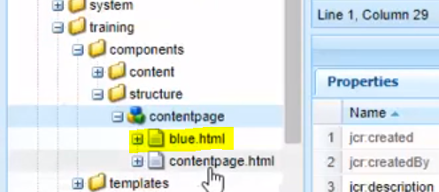

Now try to access the below URL.

<http://localhost:4502/content/we-train.blue.html>

As we have select.html file available in the component, it will render the content specified in blue.html file.

